Scrum Tools
Many tools, methods, and systems have been created to help facilitate the Scrum process. Below, you will explore some of the more common options, but first a word of advice: When choosing a system to track your Scrum team, start as lightweight as possible. It is a common pitfall that teams find themselves adopting the most sophisticated system available, when a whiteboard or sticky notes may suffice while saving time and money.

Good Old Fashioned Sticky Notes
Don't be seduced by the robust features and advanced functionality of the many scrum management systems. The simplest way to learn and explore the scrum process is the same way it was created. By using Sticky Notes and some space on a wall.
If you think back to the previous lessons, the essential aspect of tracking boils down to:
- The status of the current sprint
- The product backlog
Therefore, merely creating some swim lanes on a wall with masking tape and tracking your stories by writing them on sticky notes is often a convenient and manageable method for organizing your sprints.


Atlassian JIRA
Atlassian is the developer of JIRA, one of the most widely adopted Scrum management systems. JIRA is a highly configurable and incredibly robust system for managing software projects through many methodologies, not limited to Scrum. Many teams have found its advanced feature set, plugin marketplace and customizable user experience to be well suited for managing software teams.
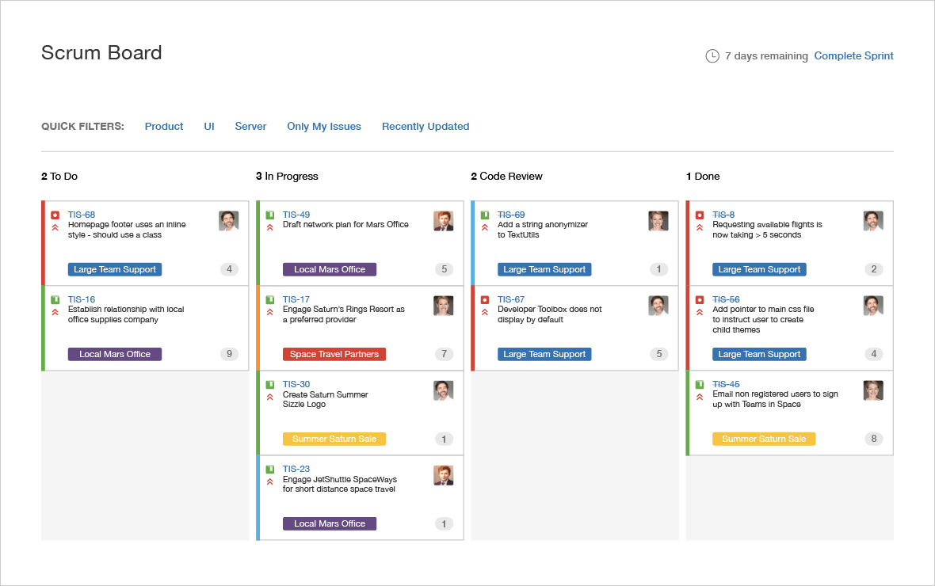

Additional Info!
You can learn more about JIRA at: atlassian.com.

Team Foundation (TFS)
Microsoft's solution to managing software teams comes in the form of Team Services, as a cloud-based solution or Team Foundation System as an on-premise solution.
Team Services offers many of the same features as JIRA while being more tightly integrated with the Microsoft platform and integrated source control. This is an excellent solution for .NET developers.
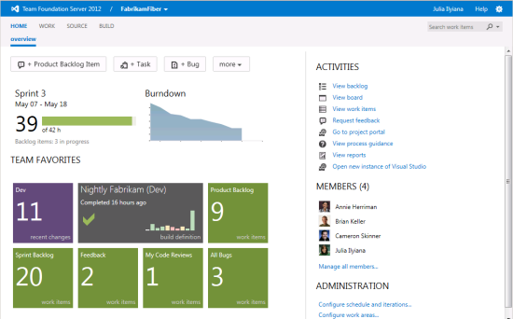

Additional Info!
You can learn more about Team Services at: visualstudio.com.

Trello
Over the past few years, Trello has rapidly gained in popularity due to is lightweight user experience and free option for small teams. Trello is easily the most limited solution presented here, but has a very low learning curve and mimics the sticky-note format incredibly well. If you are learning scrum, looking for a lightweight solution with virtually no setup involved, Trello is a great option for you.
It's for this reason that you should begin with Trello, especially for teams with remote members. As you become more familiar with the Scrum process, you are encouraged to explore some of the other available tools.
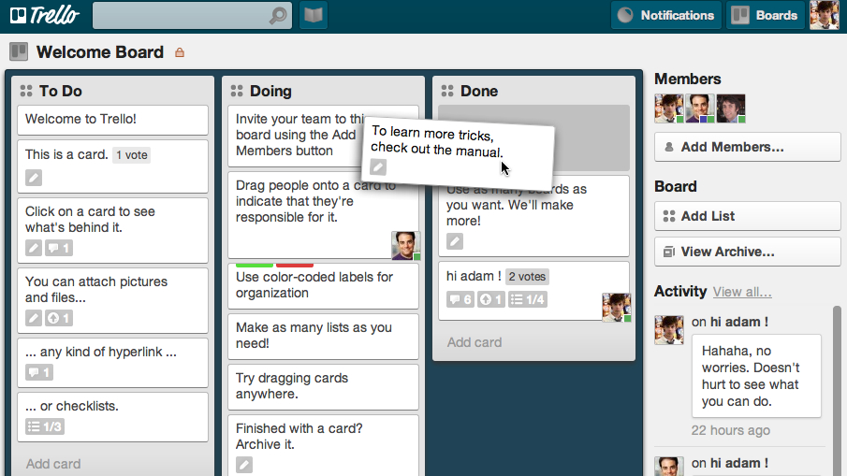

Additional Info!
You can learn more about Trello at: trello.com.

